Understanding the export of biogenic particles in oceanic waters: Is there consensus?
Boyd et al., 2007
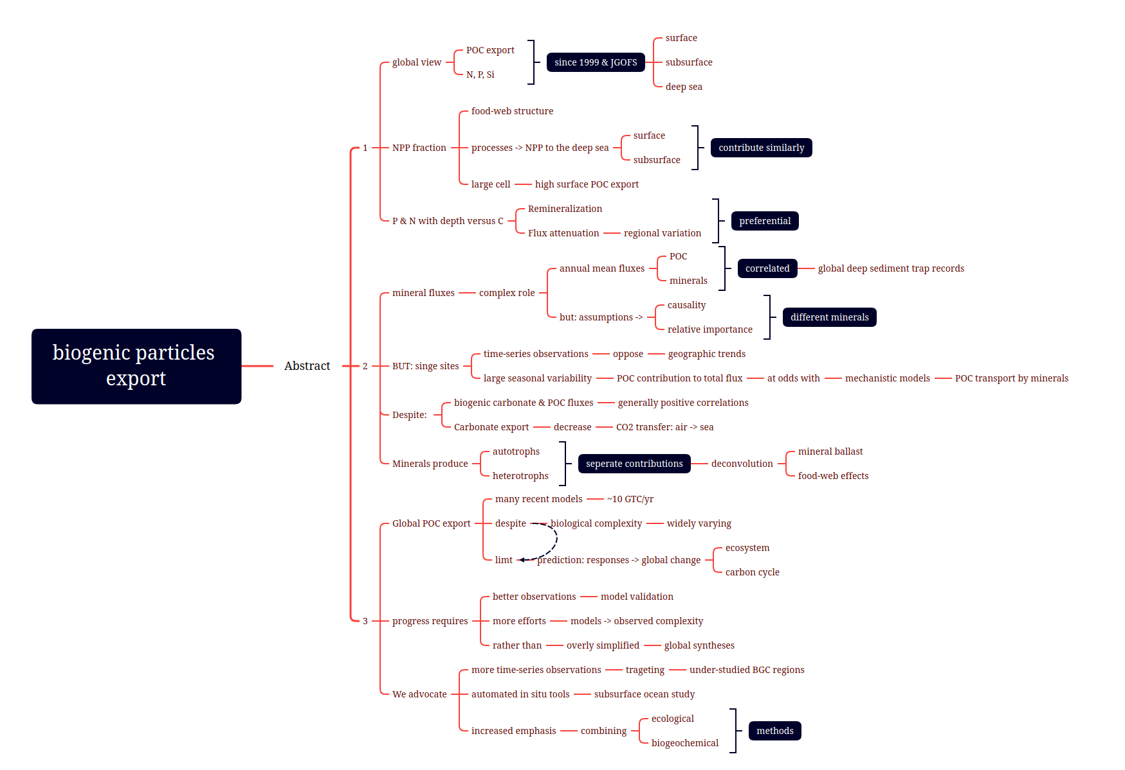
We examine progress towards a global view of oceanic export of particulate organic carbon (POC) and other nutrient elements (P, N, Si) from the surface (upper 100 m), through the subsurface, to the deep sea (>1000 m), focusing on syntheses published since 1999 and on the Joint Global Ocean Flux Study. Food-web structure is important, and surface and subsurface processes contribute similarly to determine the fraction of net primary production (NPP) reaching the deep sea. NPP by large cells generally favours high surface export of POC. Preferential remineralization of P and N (versus C) with depth is common, as is regional variation in subsurface POC flux attenuation.
The role of mineral fluxes is complex. Annual mean fluxes of POC and minerals are correlated in global deep sediment trap records, but causality and the relative importance of different minerals depends on the assumptions made. Time-series observations at single sites can oppose the geographic trends, and their large seasonal variability in the contribution of POC to total flux is at odds with mechanistic models for POC transport by minerals. Despite generally positive correlations between biogenic carbonate and POC fluxes, the overall role of carbonate export is to decrease the transfer of carbon dioxide from the atmosphere to the ocean. Both autotrophs and heterotrophs produce minerals, and progress in separating these contributions is required for the deconvolution of mineral ballast and food-web effects.
Many recent models suggest global surface POC export of ∼10 GTC/yr, despite widely varying biological complexity. This limits the usefulness of their prediction of ecosystem and carbon cycle responses to global change. Progress requires better observations for model validation, and more efforts to relate the models to the observed complexity, rather than to overly simplified global syntheses. We advocate more time-series stations targeting under-studied biogeochemical regions, development of automated in situ tools for study of the subsurface ocean, and increased emphasis on combining ecological and biogeochemical methods.

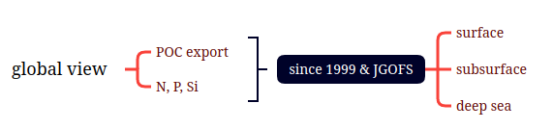
We examine a global view of the export of biogenic particles and other minerals (N, P, Si) from the surface through the subsurface to the deep sea by combining the studies since 1999 and the Joint Global Ocean Flux Study.
We examine progress towards a global view of oceanic export of particulate organic carbon (POC) and other nutrient elements (P, N, Si) from the surface (upper 100 m), through the subsurface, to the deep sea (>1000 m), focusing on syntheses published since 1999 and on the Joint Global Ocean Flux Study.
We examine progress towards a global view of oceanic export of particulate organic carbon (POC) and other nutrient elements (N, P, Si) from the surface through the subsurface to the deep sea, focusing on the syntheses published since 1999 and on the Joint Global Ocean Flux study.
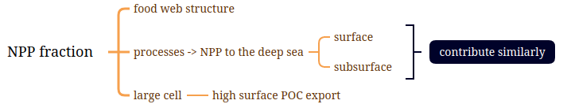
Food web structure is important and surface and subsurface processes contribute similarly for the net primary production reaching the deep sea. Large cells tends to export high POC from the surface.
Food-web structure is important, and surface and subsurface processes contribute similarly to determine the fraction of net primary production (NPP) reaching the deep sea. NPP by large cells generally favours high surface export of POC.
Food web structure is important, and surface and subsurface processes contribute similarly to determine the fraction of net primary production (NPP) reaching the deep sea. NPP by large cells generally favours high surface export of POC.
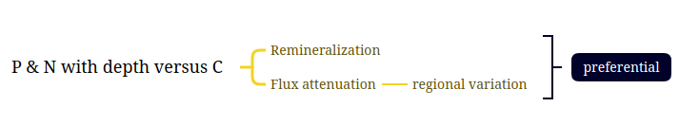
Preferential remineralization of P and N (versus C) with depth is common, so as the regional variation of subsurface flux attenuation.
Preferential remineralization of P and N (versus C) with depth is common, as is regional variation in subsurface POC flux attenuation.
Preferential remineralization of P and N (versus C) with depth is common, as is regional variation in subsurface POC flux attenuation.

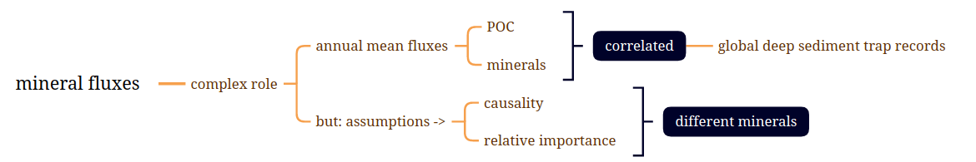
The role of mineral fluxes is complex. Annual mean fluxes of POC and minerals are correlated according to the global deep sediment trap records. But the causality and relative importance of different minerals can be different and depend on the assumptions made.
The role of mineral fluxes is complex. Annual mean fluxes of POC and minerals are correlated in global deep sediment trap records, but causality and the relative importance of different minerals depends on the assumptions made.
The role of mineral fluxes is complex. Annual mean fluxes of POC and minerals are correlated in global deep sediment trap records, but causality and the relative importance of different minerals depend on the assumptions made.
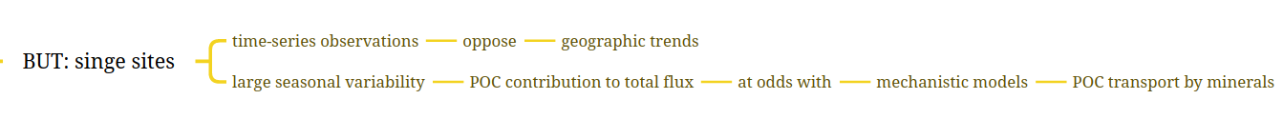
But time-series at single sites can oppose the geographic trends. Large seasonal variability in the contribution of POC to total flux is at odds with mechanistic models of POC transport by minerals.
Time-series observations at single sites can oppose the geographic trends, and their large seasonal variability in the contribution of POC to total flux is at odds with mechanistic models for POC transport by minerals.
Time-series observations at single sites can oppose the geographic trends, and their large seasonal variability in the contribution of POC to total flux is at odds with mechanistic models for POC transport by minerals.
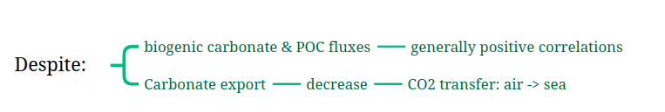
Despite the generally positive correlations between biogenic carbonate and POC fluxes, the overall role of carbonate export is to decrease CO2 transfer from the atmosphere to the deep sea.
Despite generally positive correlations between biogenic carbonate and POC fluxes, the overall role of carbonate export is to decrease the transfer of carbon dioxide from the atmosphere to the ocean.
Despite generally positive correlations between biogenic carbonate and POC fluxes, the overall role od carbonate export is to decrease the transfer of carbon dioxide from the atmosphere to the ocean.
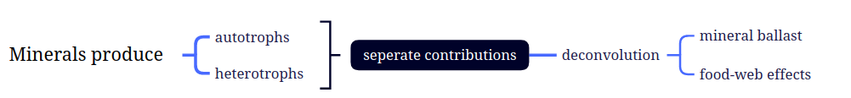
Both autotrophs and heterotrophs produce minerals, progress in seperating their contributions is important for the deconvolution of mineral ballast and food-web effects.
Both autotrophs and heterotrophs produce minerals, and progress in separating these contributions is required for the deconvolution of mineral ballast and food-web effects.
Both autotrophs and heterotrophs produce minerals, and progress in seperating these contributions is required for the deconvolution of mineral ballast and food-web effects.
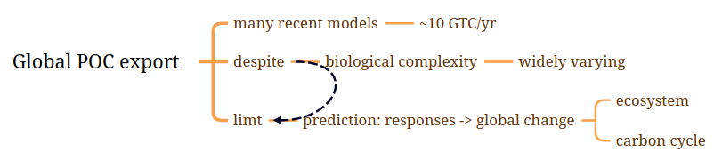
Many recent models estimate global surface POC export at 10 GTC/yr, despite the widely varying biological complexity. This limits prediction of ecosystem and carbon cycle responses to the global change.
Many recent models suggest global surface POC export of #10 GTC/yr, despite the widely varying biological complexity. This limits the usefulness of their prediction of ecosystem and carbon cycle responses to global change.
Many recent models suggest global surface POC export of 10 GTC/yr, despite the widely varying biological complexity. This limits the usefulness of their prediction of ecosystem and carbon cycle responses to global change.
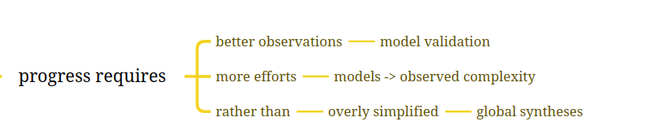
Progress requires better observations for model validation, and more efforts to link the models to observed complexity, rather than to overly simplified global syntheses.
Progress requires better observations for model validation, and more efforts to relate the models to the observed complexity, rather than to overly simplified global syntheses.
Progress requires better observations for model validation, and more efforts to relate the models to the observed complexity, rather than to overly simplified global syntheses.
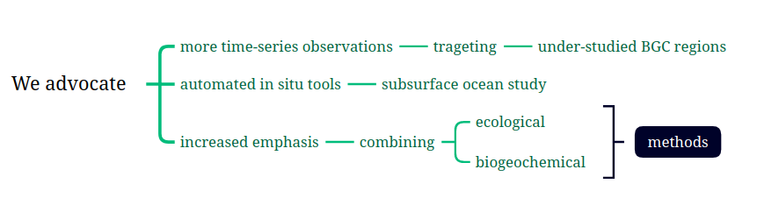
We advocate more time-series targeting the under-studied biogeochemical regions, the automated in situ tools for the study of the subsurface ocean and increased emphasis on combining the ecological and biogeochemical methods.
We advocate more time-series stations targeting under-studied biogeochemical regions, development of automated in situ tools for study of the subsurface ocean, and increased emphasis on combining ecological and biogeochemical methods.
We advocate more time-series stations targeting under-studied biogeochemical regions, development of automated in situ tools for study of the subsurface ocean, and increased emphasis on combining ecological and biogeochemical methods.

